Operating System Week-5

Name : Tanishq Vyas
SRN : PES1201800125
Section : H
Semester : 5
Branch : CSE

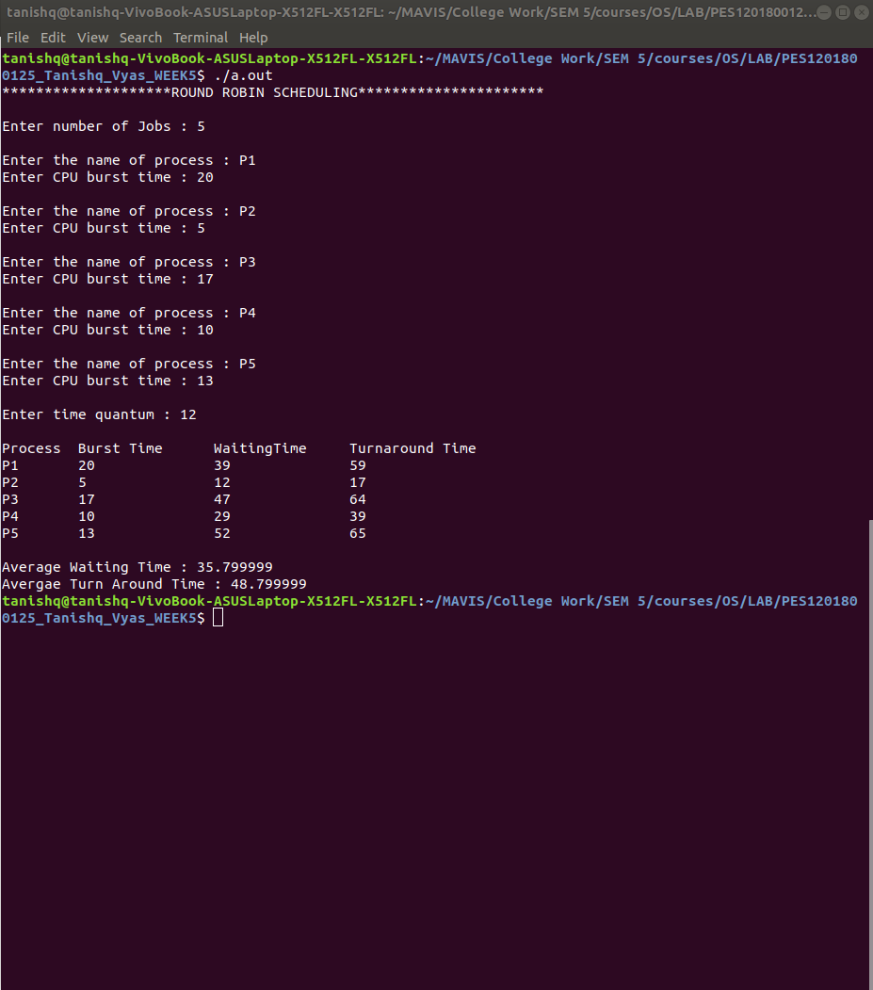
Fig : Execution for Time Quanta = 12
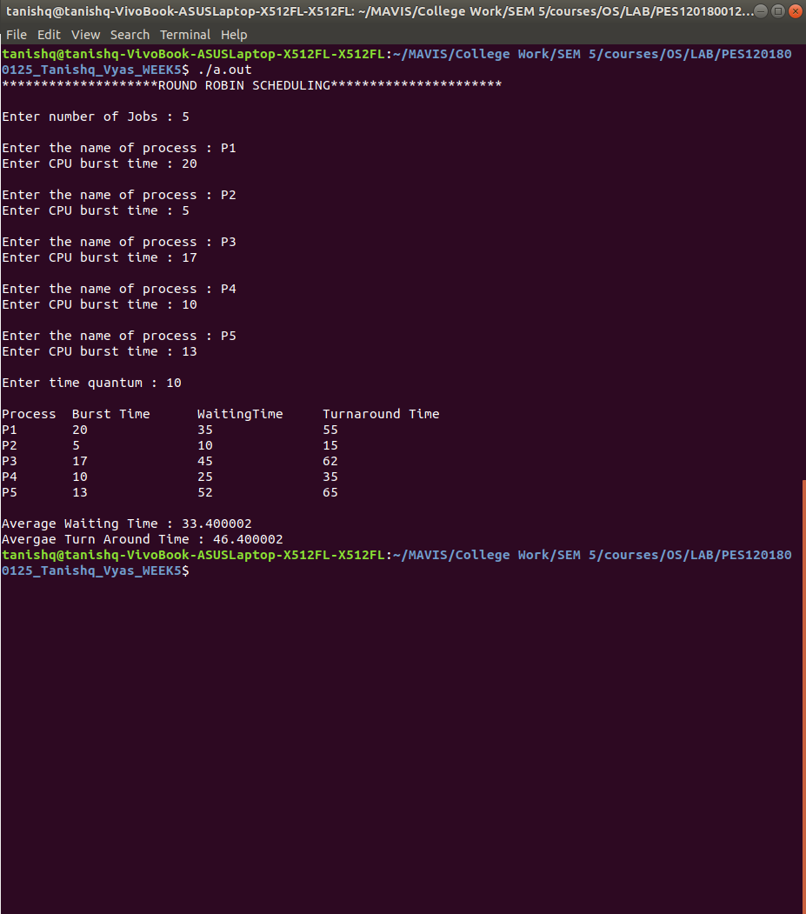

Fig : Execution for Time Quanta = 10

